Image Analysis Engine

Guide for setup and use

Table of Contents

**Setting up the Image Analysis Engine 1**

**Download 1**

**Set up folders: 2**

**Using the Image Analysis Engine 3**

**Upload the Images: 3**

**Analyze the Astrocytes: 4**

**MIT License 5**

**Appendix A: Planned updates 6**

**Appendix B: Miscellaneous 7**

**Images from development 7**

**Speed Analysis 7**

# Setting up the Image Analysis Engine

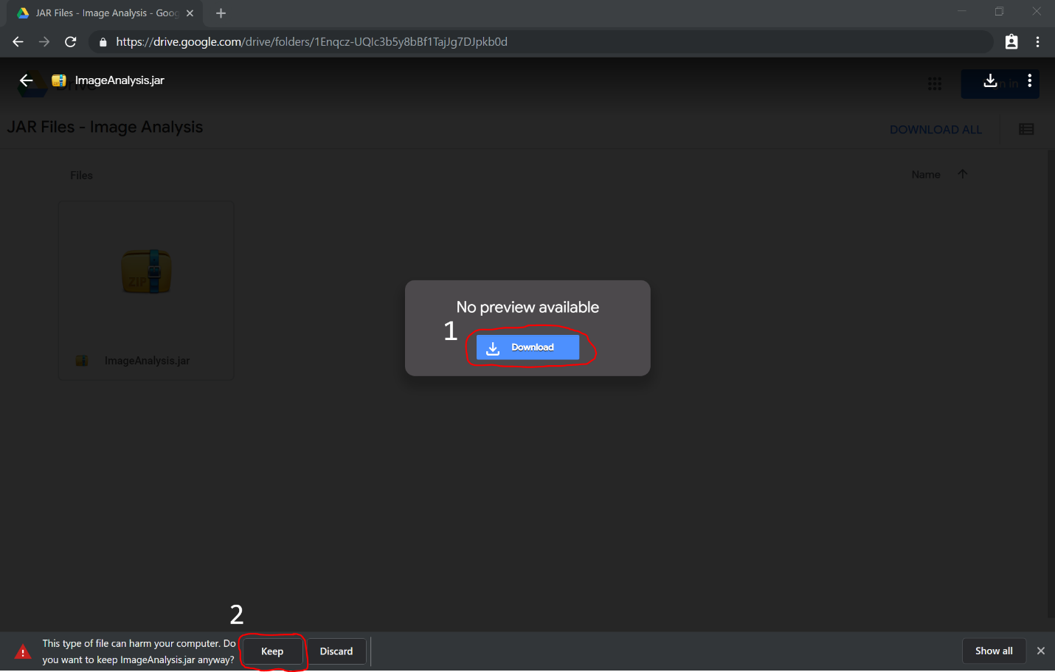

Download: Download the Image Analysis JAR file off of the Google Drive link: <https://drive.google.com/drive/folders/1Enqcz-UQIc3b5y8bBf1TajJg7DJpkb0d?usp=sharing>. If the download bar prompts you with “this type of file can harm your computer,” press the button labeled “keep”.

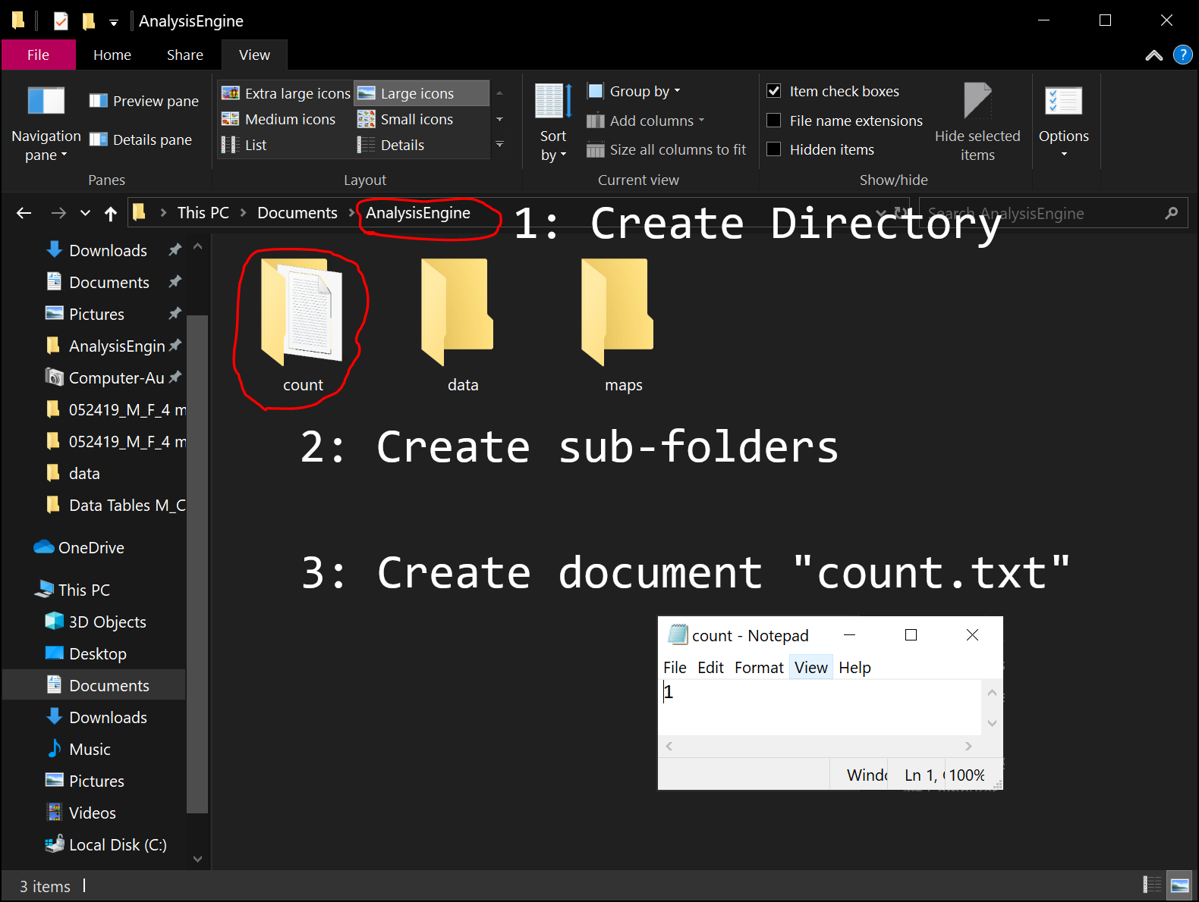

Set up folders: The Image Analysis Engine, by default, loads its analyses to a folder in the user’s documents section in the C:/ drive. Specifically, go to the path C:/Users/[username]/ Documents/AnalysisEngine. In the absence of an installer program, which hopefully will be implemented in the future, users must create these directories on their own.

Under the analysis engine’s main folder, there are three subfolders you must create. The first one is labeled “count” and contains a single count.txt file, which you can make using Notepad. This document should be saved with a single “1” to signify the next run will be the first run of the program. You should also create two other folders, “data”, and “maps”, that will record the results of the analyses that are output by the engine.

# Using the Image Analysis Engine

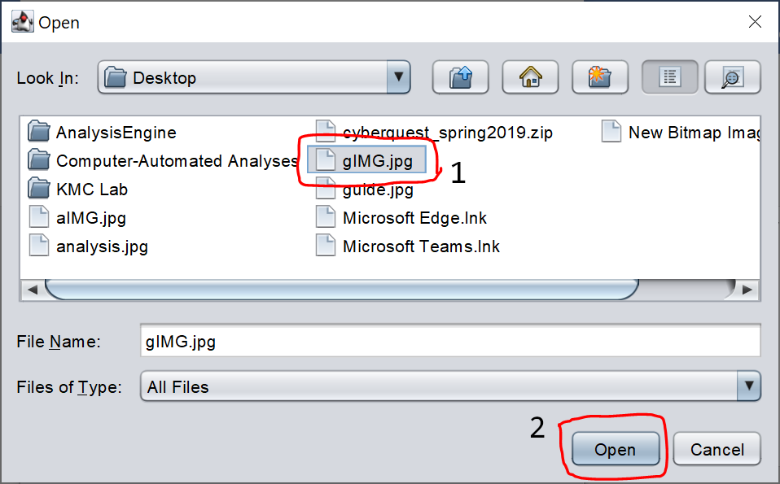Upload the Images:   
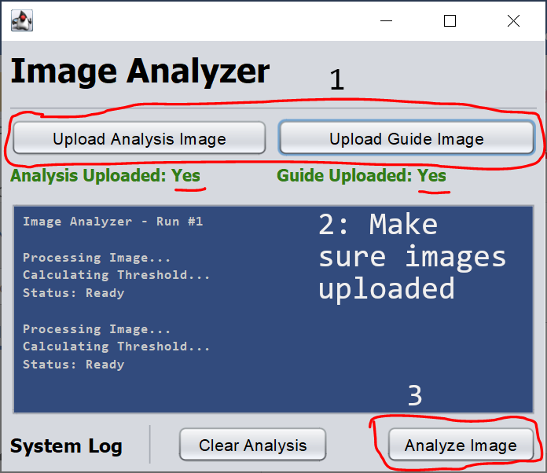

To begin, run the JAR file. Once the Java window is open, use the labeled buttons (“Upload Analysis Image” and “Upload Guide Image”) to upload your images to the analysis engine. The analysis image should be the black-and-white image of GFAP intensity that you are preparing to analyze. The guide image should be the blue-stained image of nuclei to “guide” the engine to the astrocytes of most interest.

### Analyze the Astrocytes:

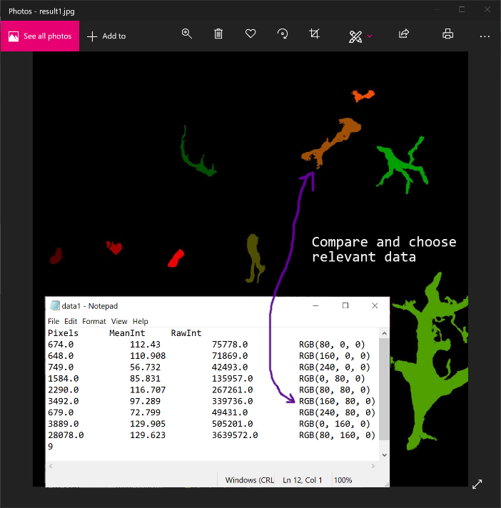After uploading the images and pressing “analyze”, the engine will show a summary of the regions analyzed in its system log (the blue box). The rest of the data will be in a file under the path C:/Users/[username]/Documents/ AnalysisEngine/data/data[run number].txt. For example, the data from the first run would be under data1.txt. In the maps folder, there is an image to complement the data. This image is named image[run number].jpg.

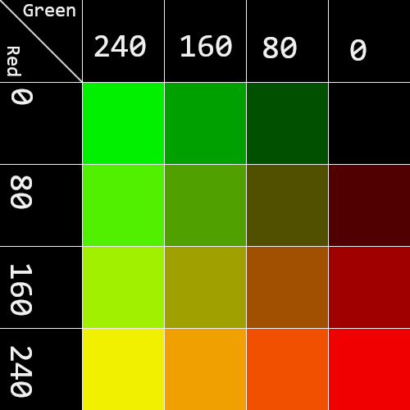If one is to analyze only a specific subset of the data, one would open both the data file and the image file. Due to the difficulty of labeling each astrocyte with text in the image, colors were used to label all astrocytes. Next to each data entry is an RGB(red, green, blue) value to indicate the color astrocyte corresponding to that set of data (although only red and green are used). For the ease of conversion, a table of red-green values converted to colors is included to the right.

After completion of the analysis, one can click the “clear analysis” button to clear variables and continue working on other images or exit the engine.

# MIT License

Copyright (c) 2019 Andy Tang

Permission is hereby granted, free of charge, to any person obtaining a copy

of this software and associated documentation files (the "Software"), to deal

in the Software without restriction, including without limitation the rights

to use, copy, modify, merge, publish, distribute, sublicense, and/or sell

copies of the Software, and to permit persons to whom the Software is

furnished to do so, subject to the following conditions:

The above copyright notice and this permission notice shall be included in all

copies or substantial portions of the Software.

THE SOFTWARE IS PROVIDED "AS IS", WITHOUT WARRANTY OF ANY KIND, EXPRESS OR

IMPLIED, INCLUDING BUT NOT LIMITED TO THE WARRANTIES OF MERCHANTABILITY,

FITNESS FOR A PARTICULAR PURPOSE AND NONINFRINGEMENT. IN NO EVENT SHALL THE

AUTHORS OR COPYRIGHT HOLDERS BE LIABLE FOR ANY CLAIM, DAMAGES OR OTHER

LIABILITY, WHETHER IN AN ACTION OF CONTRACT, TORT OR OTHERWISE, ARISING FROM,

OUT OF OR IN CONNECTION WITH THE SOFTWARE OR THE USE OR OTHER DEALINGS IN THE

SOFTWARE.

# Appendix A: Planned updates

Several updates are planned for the Image Analysis Engine.

1. Get background intensity: Teach the Image Analysis Engine to get the background of any image, most likely by analyzing a certain number of low-intensity pixels (n = 1000, 5000, or 10000, depending on circumstance)
2. Better color scheme: The current colors are hard to distinguish (especially if you have a color like (240, 0, 0) vs (240, 80, 0)). A better color scheme should be implemented to make it easier for researchers to identify astrocytes. Perhaps labels can be added to the image, however that would be hard to manage.
3. Text into Excel file: Currently the .txt files are annoyingly hard to copy into Excel. In the future I would like to directly export the results as a .xlsx file, with background and other information already recorded.
4. Bundling into .exe file: JAR files, like the one the Image Analysis engine is currently running on, are slowly losing support, as is Java. An executable file (.exe) would have more cross-platform support and would be easier to run.
5. Bundling into Windows app: Currently, .exe or .jar files are relatively hard to find: you must open many folders to try to find the file. In the future, it could be beneficial for the Image Analysis Engine to run in a windows app that could be downloaded from the web, just like ImageJ.
   1. This would also entail creating a website for the app. Such website could hold information about the app and usage instructions, as well as serving for an endpoint for downloads. In the meantime, I will move the code onto Github.
6. Machine Learning (simple linear regression) to try to identify boundaries on astrocytes. It may be possible, but it will be a lot of effort. Potentially if I can complete all the updates above (1 - 5) I will try to work on 6. Presently my current method using the threshold of one-quarter standard deviation above the mean of the image will stand in for more advanced machine recognition of astrocytes.

# Appendix B: Miscellaneous

### Images from development

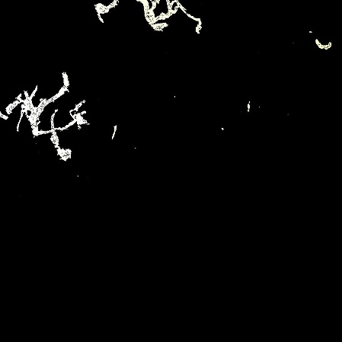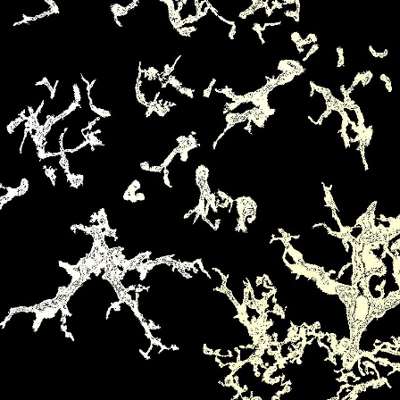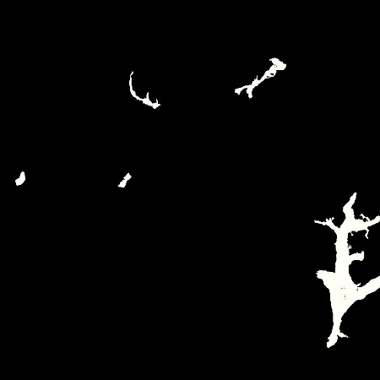

|  |  |  |
| --- | --- | --- |
| A: First image generated. However, it is incorrect. | B: Image is now mostly correct but filled with holes. | C: Threshold corrected and holes in image fixed. |

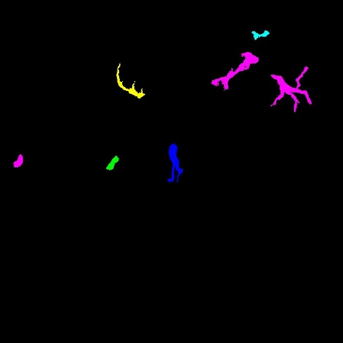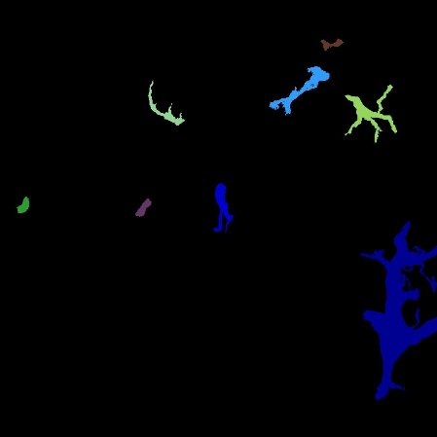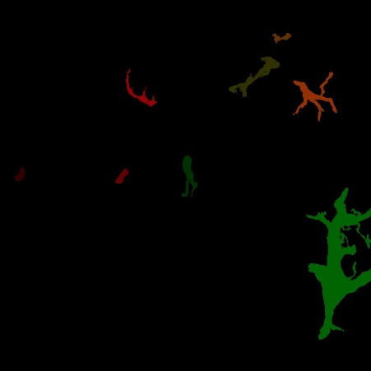

|  |  |  |
| --- | --- | --- |
| D: First image with true color scheme. However, errors in introduction led to incorrect results. | E: Image is corrected, but it is hard to tell what each color represents (see similarity in blue/green). | F: New red-green color scheme introduced. This scheme is later brightened. |

### Speed Analysis

It took about 7 minutes for me to automatically analyze 18 images. In contrast, it took a total of 15 minutes (9:30 for slide creation, 5:30 for cell identification) for me to even identify all of the cells in all 18 images. To analyze these 18 images would take me an estimated 4-5 hours at minimum. Therefore, this program drastically speeds up (at least my) image analysis.